PROGRAM 2: INSURANCE DATABASE
Query 1: Display the entire CAR relation in the ascending order of manufacturing year.

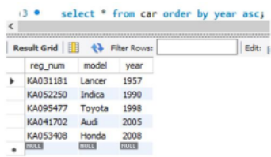
Query 2: Find the number of accidents in which cars belonging to a specific model (example 'Lancer') were involved.
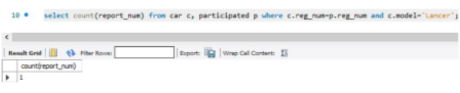
Query 3: Find the total number of people who owned cars that involved in accidents in 2008.
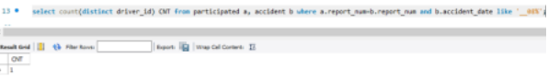

Query 4: List the entire participated relation in the Descending Order of Damage Amount.
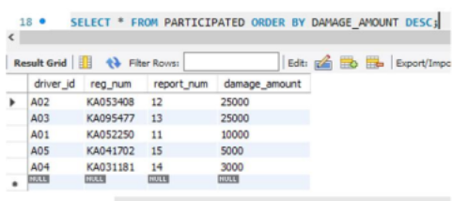

Query 5: Find the Average Damage Amount.
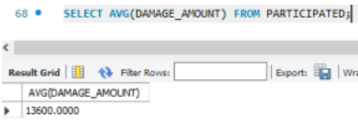
Query 8: List the name of drivers whose Damage is Greater than the Average Damage Amount.
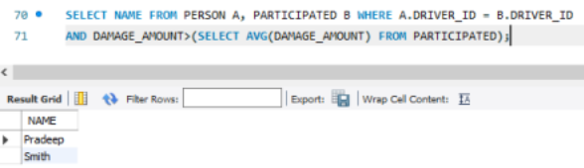

Query 9: Find Maximum Damage Amount.
